**49. Spring Security - Bootstrap CSS Login Form**

**Add Bootstrap to our logging Page**:

For make our logging page more beautiful and responsive we add bootstrap to our logging page.

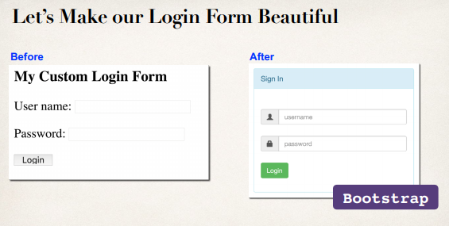

**Bootstrap**

* Bootstrap is a web framework that includes CSS styles and JavaScript
* Focused on front-end UI

**Development Process (Step-by-Step)**:

1. Modify form and add support for Spring MVC form tags
2. Update form to point to our login processing URL
3. Verify form fields for username and password
4. Change our controller to use our new Bootstrap login form

**Step-1: Modify form and add support for Spring MVC form tags**:

<%@ taglib prefix=*"form"* uri=*"http://www.springframework.org/tags/form"*%>

<%@ taglib prefix=*"c"* uri=*"http://java.sun.com/jsp/jstl/core"*%>

**Step-2: Update form to point to our login processing URL**:

action=*"*${pageContext.request.contextPath}*/authenticateTheUser"*

method=*"POST"*>

<!-- Check for login error -->

<c:if test=*"*${param.error != null }*"*>

<i class=*"failed"*>Sorry!!! You entered invalid username/password</i>

</c:if>

49. Spring Security - Bootstrap CSS Login Form